ABLEKUMA CENTRAL MUNICIPAL ASSEMBLY
ENVIRONMENTAL HEALTH AND SANITATION UNIT
REPORT ON TRAINING AND EDUCATION CARRIED OUT ON MANAGEMENT OF BIOMEDICAL WASTE IN HEALTH FACILITIES FOR HEALTH CARE PROVIDERS ON 20TH OF SEPTEMBER, 2024
INTRODUCTION:
Biomedical waste management is a critical aspect of environmental health in health facilities. Improper handling and disposal of biomedical waste pose significant risks to human health, the environment, and the community. This report highlights the importance of environmental education on biomedical waste management in health facilities.
Objectives:
1. To raise awareness among healthcare professionals on the importance of proper biomedical waste management.
2. To educate healthcare professionals on the procedures for segregation, handling, and disposal of biomedical waste.
3. To promote adherence to national and international regulations and guidelines on biomedical waste management.
Methodology:
A training program was conducted for healthcare professionals in a health facility, comprising:
1. Lectures on biomedical waste management principles, regulations, and guidelines.
2. Practical demonstrations on waste segregation, handling, and disposal.
3. Group discussions
Key Topics Covered:
1. Definition and classification of biomedical waste.
2. Risks associated with improper biomedical waste management.
3. Segregation and categorization of biomedical waste (e.g., infectious, pathological, pharmaceutical).
4. Handling and storage procedures (e.g., use of color-coded bins, labelling).
5. Disposal methods (e.g., incineration, autoclaving, landfill).
6. Personal Protective Equipment (PPE) usage.
7. Hygiene facilities (showers, toilets, etc.)
8. Emergency response procedures for spills and accidents.
Conclusion:
Environmental education on biomedical waste management is crucial for healthcare professionals. This training program demonstrated significant improvements in knowledge and adherence to proper waste management practices.

Recommendations:
1. Regular training and refresher courses.
2. Continuous monitoring and evaluation.
3. Collaboration with regulatory agencies.
Appendices:
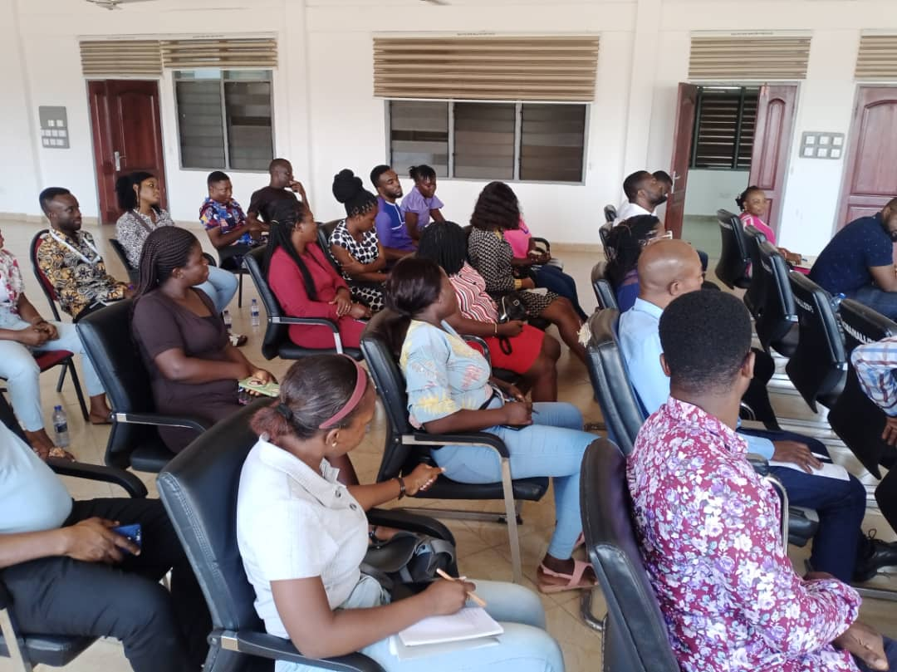Section of participant
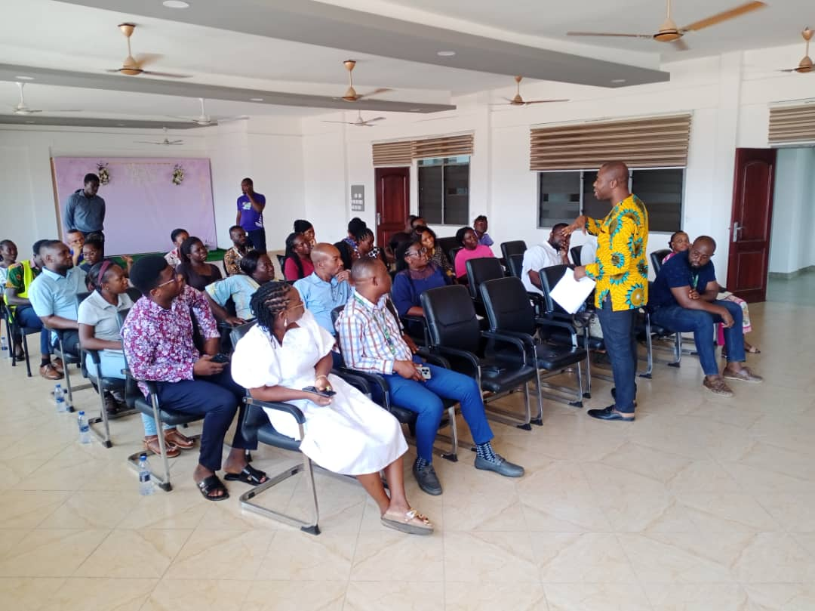E.P.A Facilitator taking participant through training
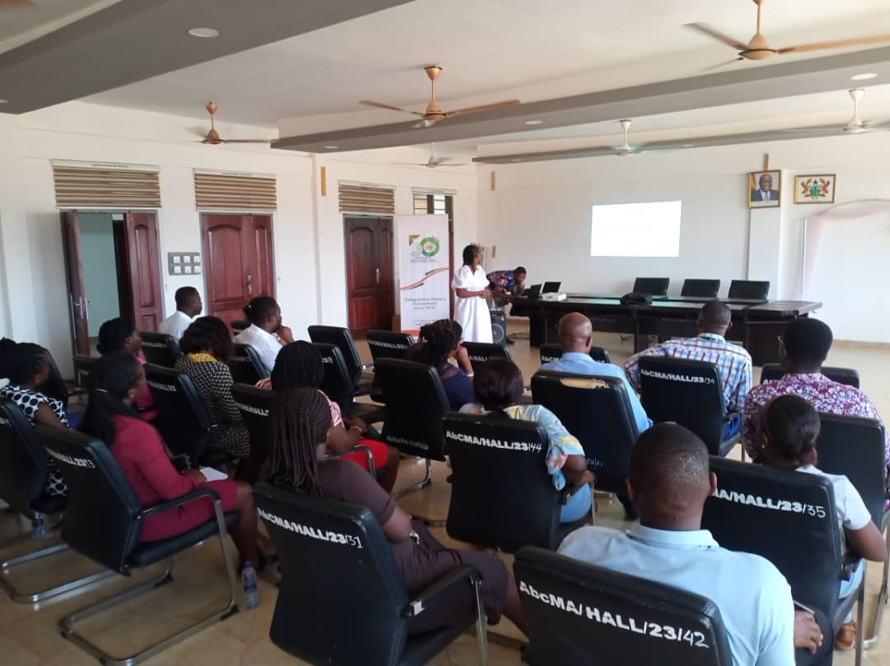E.H.O taking participants through proper handling/management of biomedical waste
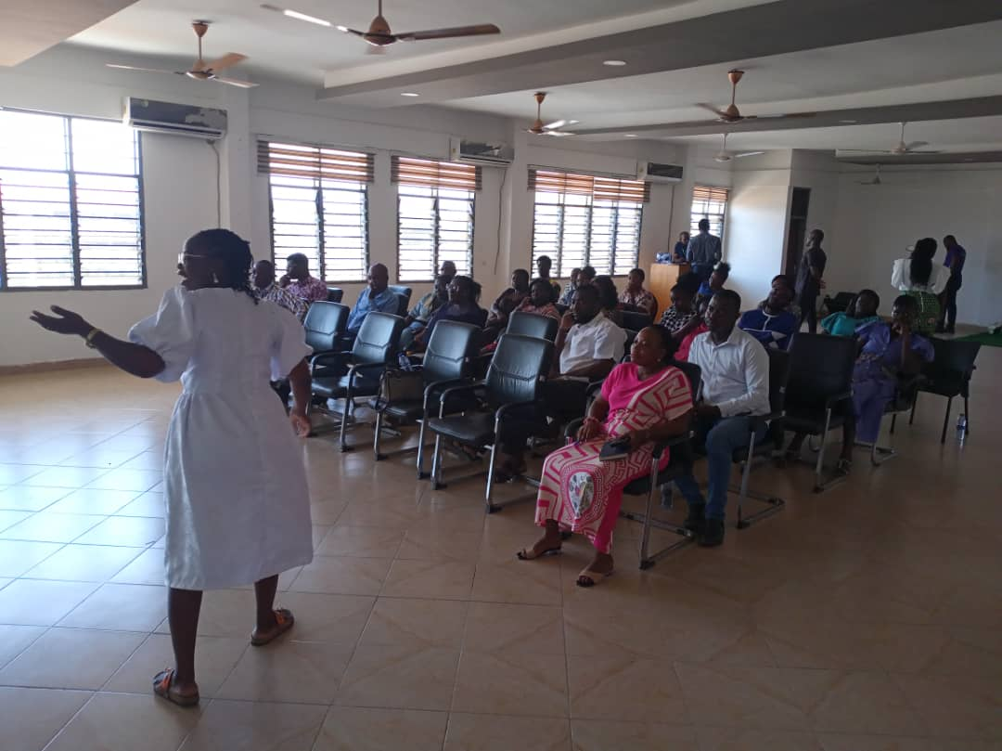E.H.O giving explanations to some slides

By prioritizing environmental education on biomedical waste management, health facilities can minimize environmental and health risks, ensuring a safer environment for patients, staff, and the community.

COMPILED BY:

BRIDGET SEYRAM DIAPIM
(MUNICIPAL ENVIRONMENTAL HEALTH OFFICER)

